
AMERICAN INTERNATIONAL UNIVERSITY-BANGLADESH (AIUB)
Department of CSE
Computer Aided Design and Drafting

Section: L
Experiment No: # 02
Name: Khan, Md. Sazzad
Id: 22–49172-3
Supervised by: MD. RAKIBUL ISLAM CHOWDHURY

Name of Experiment: Familiarization with different toolbars and command of
AutoCAD software.

AutoCAD Comments:

- How To Save File In AutoCAD :

Type options >> Enter Key >> Open and Save >> Save as: AutoCAD 2007 Drawing(*.dwg)>> OK
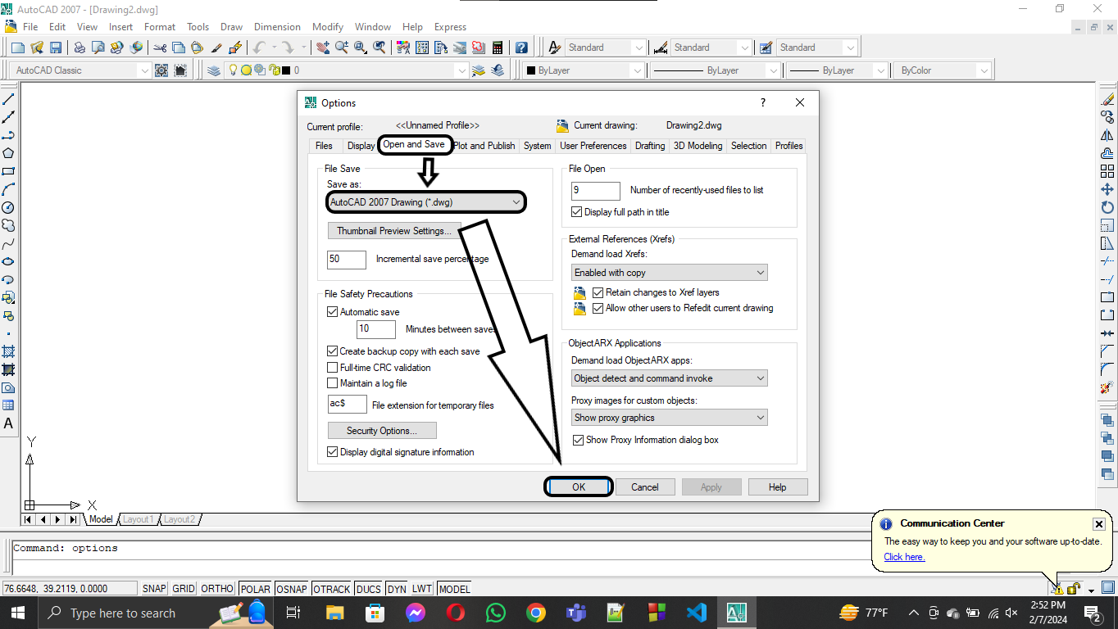

- How To Setup Units In AutoCad :

Type units>> Enter Key >> Type : Engineering, Decimal Degrees >> Precision : 0’ – 0.0” , 0 >> Scale : Inches >> OK

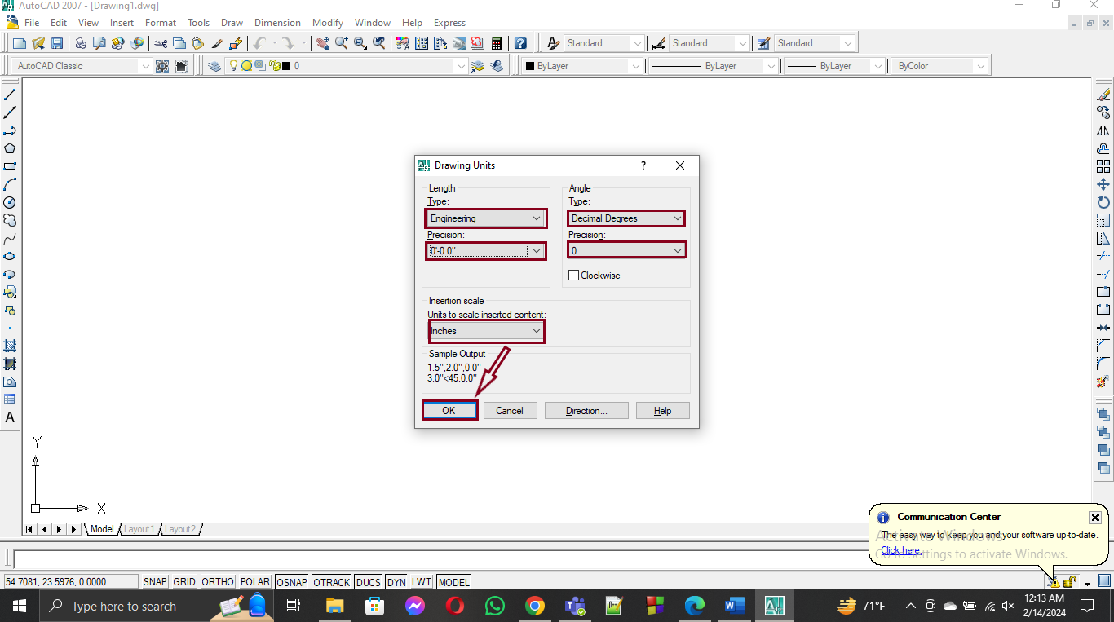

- How To Draw A Line In AutoCAD:

Type L >> Press Enter Key >> Left Click >> Put the Crosshair in the Right side and specify the Distance >> Press Enter Key >> Press Esc(Exit from Line) .

- How To Regenerate In AutoCAD:

Type regen >> Press Enter Key

- How To Dimension Style Setting In AutoCad :

- Type dimsty >> Enter Key >> modify >> Primary Units >> Unit format : Engineering >> Precision : 0’ – 0.0”

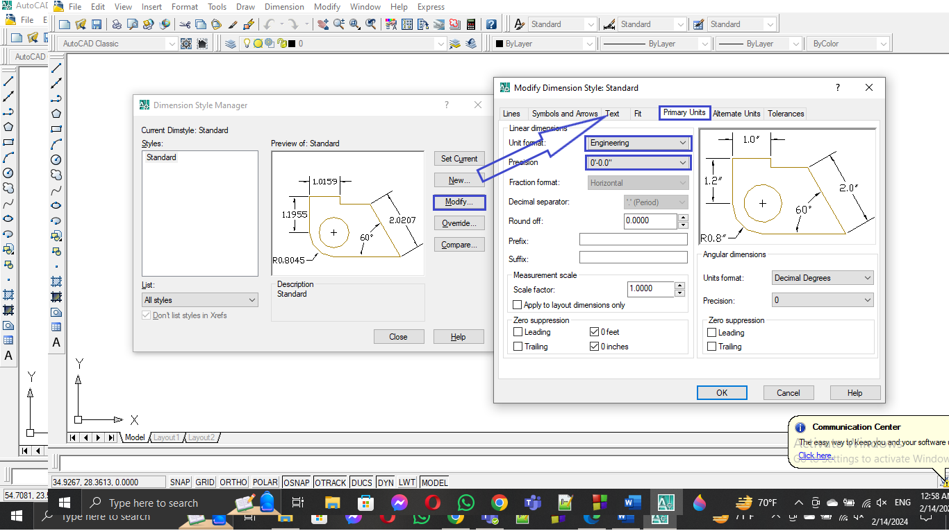

- Text >> Text Style : … >> modify >> Font Name : Times New Roman >> Height : 10” >> Apply >> Close

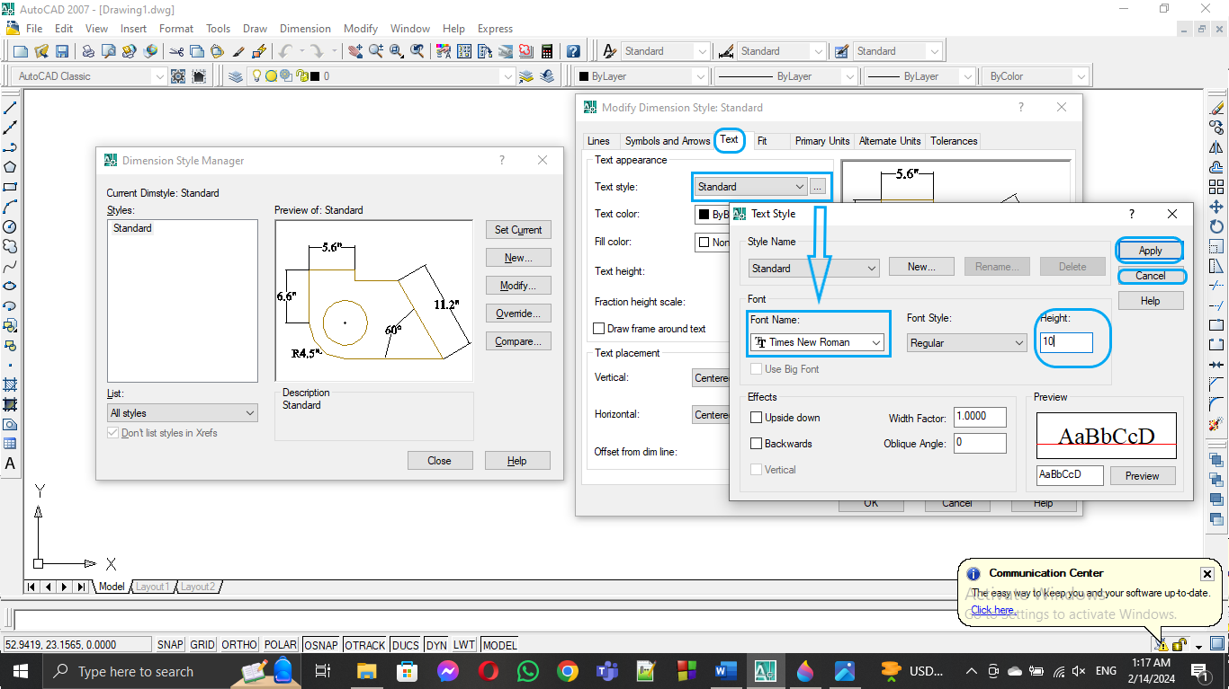

- Text >> Text Height : 10”

- Symbol and arrows >>First : Arch. Tick >> Leader : Arch. Tick >>ArrowSize: 6”

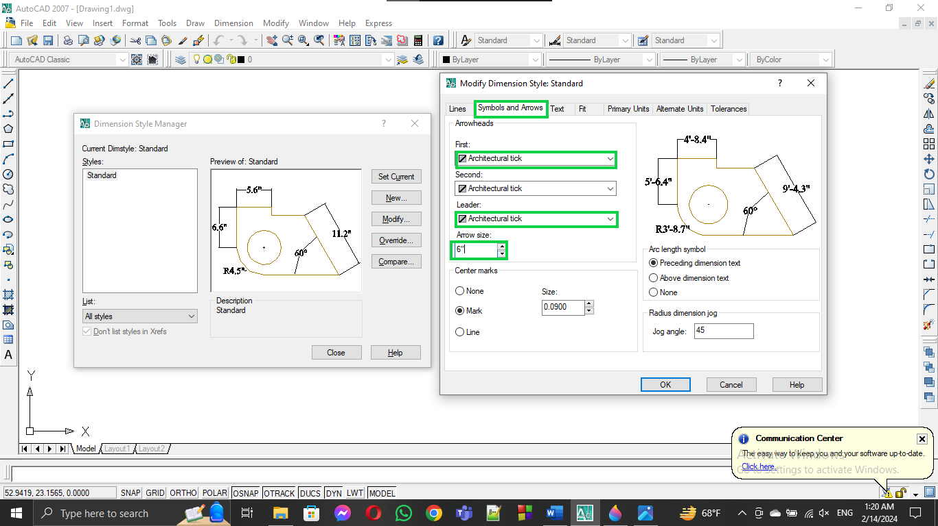

- Lines >> Extend Beyond : 6” >>Offset from Origin : 6” >> OK >> set Current >> Close

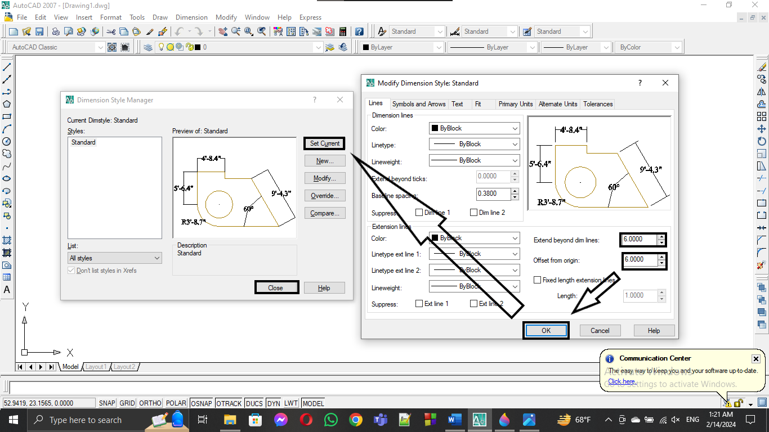

- How To Calculate Line Length In AutoCAD :

For Linear Line : Type dimlinear >> Click On First Point >> Click On Second Point >> Place the dimension line above the main line

For NonLinear Line : Type dimaligned >> Click On First Point >> Click On Second Point >> Place the dimension line above the main line

- How To Calculate Angle Between Two Lines In AutoCAD :

Type dimangular >> Click On First Point >> Click On Second Point >> Place the dimension line Between two lines .

- How To do off set operation In AutoCAD :

Type O >> Enter Key >> Specify distance >> Enter Key >> Select Object >> Click on the Side where you want to off set.

- Type tr >> Enter Key >> Enter Key

